Table of Contents

1.0 INTRODUCTION 3

2.0 QUARTER 3 DELIVERABLES 4

2.1 Review of overall plan, design and implementation of various ict projects 5

2.1.1 Introduction. 5

2.1.2 Methodology 5

2.1.3 Findings 7

2.1.4 Recommendations 9

2.2 Review of existing project closure report. 10

2.2.1 Introduction: 10

2.2.2 Digital presence 10

2.2.3 ICS – Integrated Communication Systems 11

2.2.4 Zero trust 11

2.3 Monitor the implementation of prioritized projects. 12

2.3.1 Introduction 12

2.4 Monitoring and review of network upgrade 13

2.4.1 Introduction 13

2.5 Monitoring and review of servers, storage and virtualization project 14

2.5.1 Introduction. 14

2.6 Report on various ICT projects 15

2.6.1 Introduction 15

2.6.2 Project Background: 15

2.6.3 Project Overview: 15

2.6.4 Project Details: 16

2.6.5 Achievements and Challenges: 16

2.6.6 Lessons Learned: 17

2.6.7 Impact and Benefits: 17

2.6.8 Conclusion: 17

2.7 Monitoring and review implementation of e-parliament systems 18

2.7.1 Introduction 18

2.8 Monitoring and review interactive social media and website development projects 19

2.8.1 Introduction 19

2.9 Monitoring and review of the network security project for the primary data centre. 20

2.9.1 Introduction 20

2.10 Review of training needs based on projects sheduled for the quarter for both users and technical staff. 21

2.11 Monitoring and review implementation of erp solutions 22

2.12 Submit Implementation Status 23

3.0 APPENDIX 24

3.1 Appendix: Request for documents and status of projects 24

# INTRODUCTION

Having submitted quarter 1 and 2 report, the consultants have prepared Quarter 3 report for the project management services for implementation of various ICT projects.

This report serves as a comprehensive review of our progress and achievements in fulfilling the deliverables outlined for this quarter.

In this report, we will provide detailed insights into the progress, challenges, and outcomes of each deliverable, offering stakeholders a transparent and comprehensive overview of our Quarter 3 initiatives.

# QUARTER 3 DELIVERABLES

1. Review of overall plan, design and implementation of various ICT projects.
2. Review of existing project closure report.
3. Monitor the implementation of prioritized projects.
4. Monitoring and review of Network Upgrade.
5. Monitoring and review of servers, storage and virtualization project.
6. Report on various ICT projects.
7. Monitoring and review implementation of E-Parliament systems.
8. Monitoring and review interactive social media and website development projects.
9. Monitoring and review of the Network Security project for the primary Data Centre.
10. Review if training needs based on projects scheduled for the quarter for both Users and Technical Staff.
11. Monitoring and review Implementation of ERP solutions.
12. Submit Implementation Status

## ****Review of overall plan, design and implementation of various ict projects****

### Introduction.

This critical deliverable serves as the cornerstone of PSC advancement and operational efficiency.

In this section, the consultants will provide a comprehensive analysis of the planning, design, and execution phases of the respective ICT projects as at the time of this report. This entails examining the strategic alignment of the projects with organizational objectives, evaluating the efficacy of design methodologies, and assessing the effectiveness of implementation strategies.

As at the time of this report, the consultants reviewed the overall plan, design, and implementation of the projects listed below to ensure alignment with organizational goals.

1. Digital presence
2. Online recruitment systems.
3. ICS
4. Digital congress.

### Methodology

#### Documentary Review

Comprehensive assessment of project documentation, encompassing project charters, requirements specifications, and implementation plans, with the goal of grasping the intended objectives and milestone markers. These documents, sourced from the client (PSC), are accessible upon request.

As the time of this report these are the documents received from PSC:

1. Design, Development, supply, Delivery, Installation, Testing, Commissioning, Training and Maintenance of a DIGITAL PRESENSE SOLITION (BUNGE VIRTUAL)
2. Project progress report 7th June 2022
3. Project inception report
4. System requirement document
5. Project plan
6. Solution design and building phase –Bunge virtual infrastructure
7. System Architecture document
8. System security document
9. Application Programming Interface (API)
10. Cloud hosting
11. Multifactor Authentication (MFA) document
12. Training plan
13. Test script
14. User Manual
15. Moderator user manual
16. Application Installation Manual
17. System Admin Manual
18. Training report
19. Training attendance register- committee directorate-27 02/07/2021
    * + - 1. Directorate of departmental committees 11 trained-01/10/2021
          2. Implementation committee 16 trained 22nd march 2022
          3. N/A Hansard/audio 17 trained 2/07/2021
          4. Audit, appropriation and other select committees training &national
          5. Assembly board of management 29 trained 12 &13/7/2021
          6. National Assembly Board of Management 17 sensitized 29/6/2021
          7. Legislative &Procedural department sensitization 28 trained 3/09/2021
          8. Legislative and procedural department system testing 27 trained 1/7/2021
          9. Catering committee sensitization 16 trained 31/5/2021
20. System integration
21. User Acceptance testing sign off
22. PSC – ORS (Online Recruitment System) - Sign Off Document.
23. ORS - Project Blueprint - May 2020
24. PSC Contract for ORS 2020
25. Sign off –contract-two years 23-12-20-ORS
26. List of issues sent to the vendor on 8th Feb 2024 for a simulated demo.
27. The utilization report for ICS (E-File & E-Mail) for each month from the date of go live. Utilization reports (after Go live), i.e.  Aug, Sept, Oct, Nov, Dec and Jan 2024 are attached.
28. Issue Trackers – all the issues captured after it has gone live. All issues have been captured on the Monthly Support Report/Issue tracker which are also attached.
29. Training Reports – If any training scheduled for the users after it has gone live. We have conducted an informal/non-planned training session which involves on the job demos sessions specifically to records departments, ICT and ICT Interns.
30. Feedback – If any feedback / suggestions captured from the users.

#### Technical Evaluation:

Performing a technical evaluation of the infrastructure, security protocols, and alignment with industry standards for each project.

#### User Feedback Analysis:

Examining user feedback and support tickets to assess user experiences and pinpoint possible areas of concern.

### Findings

#### Digital presence

The project was awarded to a consortium comprising (Eastern Software System LTD, Luminous Infoways Private Limited India, Tuxinofonomist Software, and Consultancy India). It commenced on March 24, 2022, with an anticipated completion date of October 31, 2022, spanning a duration of 7 months.

The objective of the Digital Presence project is to facilitate both chamber sittings and committee work, as well as to support virtual and physical proceedings. Additionally, it aims to improve the online visibility and communication of the PSC with the public and stakeholders. The initiation of the Digital Presence project aimed to establish and manage an interactive online platform for the PSC, encompassing the PSC website, social media channels, and other digital communication tools.

This evaluation examined the project's functionality and its alignment with the business requirements of the PSC.

Reviewing the overall plan and design of digital presence project involves examining various aspects to ensure that the project is well-conceived, organized, and designed to meet its objectives effectively. This typically includes:

1. **Project Objectives and Scope**:

**Technical Architecture**:

**System Design**: The consultants analyzed the digital presence system design, including user interfaces, data models, workflows, and algorithms, to ensure they meet functional requirements and provide an intuitive and efficient user experience.

**Security and Compliance**: The consultants reviewed the security measures, data protection mechanisms, and compliance with relevant regulations and standards to mitigate risks and ensure data confidentiality, integrity, and availability.

**Performance and Scalability**: The consultants evaluated the performance needs, scalability alternatives, and capacity arrangements to guarantee the system's capability to manage projected demands and adapt to future expansion

**Risk Management**: As part of the activities in this quarter, the consultants identified potential risks and developed strategies to mitigate them concerning technology, resources, timelines, dependencies, and external factors. This was aimed at reducing project disruptions and avoiding delays.

**Quality Assurance**: The consultants implemented quality assurance procedures, incorporating testing methods, defect handling, and validation criteria, to guarantee that the final solution meets both quality benchmarks and user expectations.

**Documentation and Governance**: the consultants ensured comprehensive project documentation, encompassing requirements specifications, design documents, test plans, and user manuals. Additionally, they established governance mechanisms to track project progress and ensure accountability.

The consultants undertook the task of ensuring thorough project documentation, which included reviewing of the requirements specifications, design documents, test plans, and user manuals. Additionally, they implemented governance mechanisms to monitor project progress and uphold accountability.

#### Online recruitment system.

Introduction

The contract for executing the Online Recruitment System (ORS) project was awarded to M/S Trinate Global Limited, in collaboration with M/S Hsenid Business Solutions (Pvt) Limited. Project activities officially commenced on April 15, 2020, with an intended timeframe of 8 weeks, aiming for completion by June 10, 2020.

The primary objective of the Online Recruitment System is to streamline and enhance the employee recruitment process for the HR department of PSC. Through this system, job seekers will have the convenience of accessing advertised positions on the PSC website and submitting their applications efficiently.

The implemented modules as part of the system encompass:

1. Vacancy Creation and Posting
2. User Registration
3. Job Application Module
4. Evaluation Module
5. Aptitude Testing Module
6. Interview Module
7. Due Diligence Process
8. Integration with Smart HRMS
9. Reporting Module j) Notifications

### Recommendations

Recommendations

## Review of existing project closure report**.**

### Introduction:

This deliverable presents a thorough evaluation of the existing Project Closure Report. The review aims to assess the quality and completeness of the documentation produced at the conclusion of existing projects. By scrutinizing the closure report, this review endeavors to identify key insights, successes, and areas for improvement, ultimately contributing to enhanced project management practices within the organization.

The consultants conducted a thorough review of existing project closure reports to identify lessons learned and best practices that were available.

As of the time of this report, we have received closure reports for three projects:

1. Digital Presence Project,
2. ICS,
3. Zero Trust

### Digital presence

#### Introduction:

The aim of the Digital Presence project is to streamline chamber sittings and committee operations while facilitating both virtual and in-person proceedings

#### Review Methodology:

.

#### Findings and Analysis:

* Present the findings of the review in a systematic manner.
* Evaluate various aspects of the Digital Presence project, including:
  + Project objectives and alignment with organizational goals.
  + Implementation strategies and methodologies.
  + Stakeholder engagement and satisfaction.
  + Technical infrastructure and functionality of digital platforms.
  + Compliance with industry standards and best practices.
  + Effectiveness of communication and outreach efforts.
  + Challenges faced and lessons learned.
* Provide analysis and interpretation of the findings, highlighting strengths, weaknesses, and areas for improvement.

#### Recommendations:

* Based on the findings and analysis, propose recommendations for enhancing the Digital Presence project.
* Offer practical suggestions for addressing identified weaknesses and maximizing project impact.
* Prioritize recommendations based on urgency and feasibility..

• Appendices:

* Include any additional supporting documentation or data used in the review.
* This may include project documents, survey results, stakeholder feedback, etc.

### ICS – Integrated Communication Systems

#### Introduction:

#### Review Methodology:

#### Findings and Analysis:

#### Recommendations:

• Appendices:

Include any additional supporting documentation or data used in the review.

This may include project documents, survey results, stakeholder feedback, etc.

### Zero trust

#### Introduction:

#### Review Methodology:

#### Findings and Analysis:

#### Recommendations:

• Appendices:

* Include any additional supporting documentation or data used in the review.
* This may include project documents, survey results, stakeholder feedback, etc.

## ****Monitor** **the implementation of prioritized projects.****

### Introduction

## ****Monitoring and review of network upgrade****

### ****Introduction****

For this task, the consultants were ready to conduct a thorough assessment and review of the PSC network upgrade, aimed at improving network performance and reliability to facilitate organizational operations.

However, at the time of this report, this action was not feasible as the project had not yet commenced. This information was confirmed via email from the CIT secretariat on February 7th, 2024, with a screenshot provided in the appendix.

## ****Monitoring and review of servers, storage and virtualization project****

### ****Introduction****.

The consultants were tasked with meticulously overseeing and evaluating the servers, storage, and virtualization project, with the aim of optimizing resource usage and ensuring smooth integration with the current infrastructure.

However, they were unable to proceed with this task at the time of the report, as the project had not yet been initiated. This information was communicated to us via email from the CIT secretariat on February 7th, 2024, with a screenshot provided in the appendix.

## ****Report** **on various ICT projects****

### ****Introduction****

This report provides a comprehensive overview and analysis of various ICT (Information and Communication Technology) projects undertaken within PSC. The report aims to evaluate the successes, challenges, and impacts of these projects. By examining the scope, objectives, achievements, and lessons learned from each project, stakeholders can gain valuable insights into the organization's ICT landscape and identify opportunities for future improvement and strategic alignment.

As at the time of this report the consultants are able to deliver a report on the following projects:

1. digital congress
2. Digital presence
3. Online recruitment system

### Project Background:

#### Digital congress

#### Digital presence

#### Online recruitment system

* Summarize the background and objectives of each ICT project.
* Include details such as project scope, stakeholders, timeline, and budget.

### Project Overview:

#### Digital congress

#### Digital presence

#### Online recruitment system

* Provide a high-level overview of each ICT project, highlighting its main goals, deliverables, and intended outcomes.
* Include key milestones achieved and any significant challenges encountered during project implementation.

### Project Details:

#### Digital congress

#### Digital presence

#### Online recruitment system

* For each ICT project, provide a more detailed analysis of its components, including:
  + Technical infrastructure: Describe the hardware, software, and networking components involved.
  + Implementation approach: Explain the methodology and strategies used to execute the project.
  + Stakeholder engagement: Discuss how stakeholders were involved throughout the project lifecycle.
  + Budget and resources: Outline the financial resources and human capital allocated to each project.
  + Timeline: Detail the project timeline, including key milestones and deadlines.

### Achievements and Challenges:

#### Digital congress

#### Digital presence

#### Online recruitment system

* Evaluate the achievements and successes of each ICT project against its stated objectives.
* Discuss any challenges or obstacles encountered during project implementation and how they were addressed.

### Lessons Learned:

#### Digital congress

#### Digital presence

#### Online recruitment system

* Reflect on the lessons learned from each ICT project, including what worked well and areas for improvement.
* Provide recommendations for future projects based on these insights.

### Impact and Benefits:

#### Digital congress

#### Digital presence

#### Online recruitment system

* Assess the impact and benefits of each ICT project on the organization, its stakeholders, and end-users.
* Measure outcomes against initial project goals and objectives.

### Conclusion:

* Summarize the key findings and insights gained from reviewing the various ICT projects.
* Emphasize the importance of continuous improvement and learning from past projects.

• Appendices:

* Include any additional supporting documentation, data, or detailed project plans related to the ICT projects reviewed.

## ****Monitoring and review implementation of e-parliament systems****

### ****Introduction****

This deliverable serves as an introductory overview of the comprehensive assessment that is to be conducted on E –parliament systems inn this quarter. This was to provide PSC with a detailed evaluation of the successes, challenges, and impacts of these initiatives. By meticulously examining the scope, objectives, achievements, and lessons learned.

At the time of drafting this report, the E-Parliament project had not been initiated, resulting in the inability to fulfill this deliverable. The consultants received this update from the CIT secretariat via email on February 7th, 2024. Please refer the appendix for further details.

## ****Monitoring and review interactive social media and website development projects****

### **Introduction**

The main goal of this deliverable is to present a thorough overview and assessment of the progress, effectiveness, and impact of these projects. By systematically monitoring and evaluating the development of interactive social media platforms and websites, stakeholders can gain valuable insights into their performance, user engagement, and alignment with organizational goals. The consortium aims to assess the accomplishments, obstacles, and lessons learned from these projects, providing recommendations for improvement and strategic alignment as needed.

However, as of the report compilation, the project has not yet commenced, which has impeded the completion of this deliverable. This information was communicated to the consultants by the CIT secretariat via email on February 7th, 2024. Further details are available in the appendix.

## ****Monitoring and review of the network security project for the primary data centre.****

### ****Introduction****

This deliverable initiates the official report focused on monitoring and reviewing the network security project for the primary data center. Its objective is to provide a thorough assessment of the security measures implemented within the data center, offering insights into their effectiveness and alignment with industry standards. The consortium is to evaluate the achievements, challenges, and lessons learned, providing recommendations for improvement and alignment with PSC Network security and primary Data center objectives.

At the time of drafting this report, the Network security project for the primary Data center project had not been executed, thus rendering this deliverable unfeasible

The consultants received this information via an email from the CIT secretariat dated February 7th, 2024. Please consult the appendix for further details.

## ****Review of training needs based on projects scheduled for the quarter for both users and technical staff**.**

## ****Monitoring and review implementation of erp solutions****

This deliverable offers an overview of the monitoring and review process for the implementation of ERP (Enterprise Resource Planning) solutions. The part of the report aims to provide a comprehensive analysis of the progress and effectiveness of ERP implementation within the PSC. Through systematic monitoring and review, PSC can gain insights into the alignment of ERP solutions with organizational goals and their impact on operational efficiency. The Consultants were to report on achievements, challenges, and lessons learned from ERP implementation projects, along with providing recommendations for improvement and strategic alignment.

As at the time of preparing this report this project had not been implemented and therefore this deliverable could not be carried out on the E-Parliament project. The consultants got this information through the CIT secretariat through email on 7th February 2024.Please refer to appendix

## ****Submit Implementation Status****

# APPENDIX

## Appendix: Request for documents and status of projects

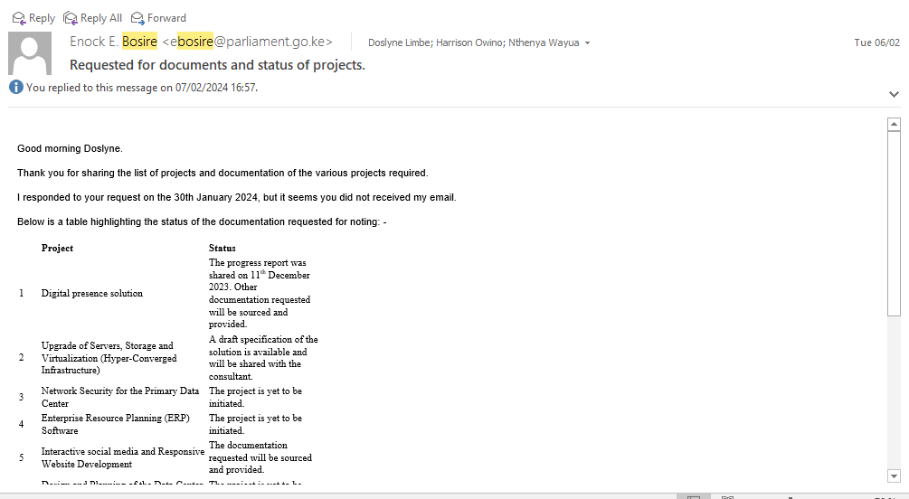

Figure 1: Request for documents and status of projects

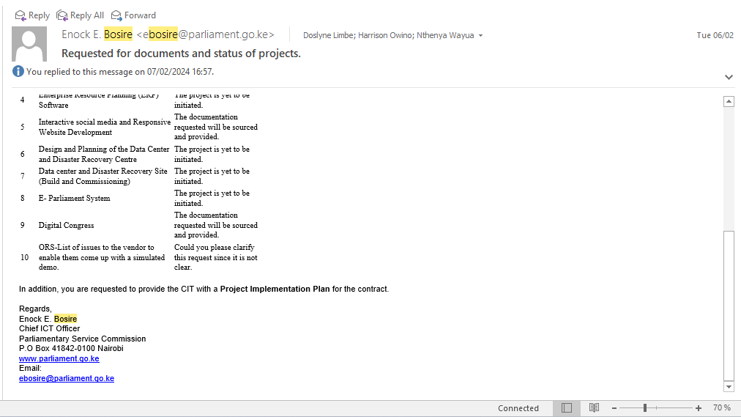

Figure 2: Request for documents and status of projects 2 continuation